ARTIFICIAL INTELLIGENCE LAB EXPERIMENTS

Name : J . Anisha Jenifer
Reg no : 192511004

Experiment 14: Decision Tree Classification

Aim
To implement a Decision Tree classifier in Python and predict the class of a new sample.

Algorithm
1. Import the Decision Tree classifier.
2. Prepare the training features and class labels.
3. Create the Decision Tree model.
4. Train the model using the training data.
5. Read a new sample from the user.
6. Predict and display the class.

Pseudo Code
START
Import DecisionTreeClassifier
Define training data X and labels y
Create the classifier
Train the classifier using X and y
Read two feature values
Predict the class
Display the result
STOP

Python Code
from sklearn.tree import DecisionTreeClassifier
# Training data: [hours studied, attendance percentage]
X = [
[1, 40],
[2, 50],
[3, 60],
[4, 70],
[5, 80],
[6, 90]
]
# 0 = Fail, 1 = Pass
y = [0, 0, 0, 1, 1, 1]
model = DecisionTreeClassifier(random_state=0)
model.fit(X, y)
hours = float(input("Enter hours studied: "))
attendance = float(input("Enter attendance percentage: "))
prediction = model.predict([[hours, attendance]])[0]
if prediction == 1:
print("Prediction: Pass")
else:
print("Prediction: Fail")

Sample Input
Enter hours studied: 5
Enter attendance percentage: 82

Sample Output
Prediction: Pass

Result
Thus, the Decision Tree classification program was implemented successfully.

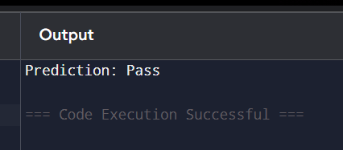

Experiment 15: Feed-Forward Neural Network

Aim
To implement a simple Feed-Forward Neural Network in Python for learning the AND logic function.

Algorithm
1. Import NumPy and define the AND gate training data.
2. Initialize weights and bias.
3. Perform forward propagation using sigmoid activation.
4. Calculate the prediction error.
5. Update weights and bias using gradient descent.
6. Repeat the training for a fixed number of epochs.
7. Read two binary inputs and display the predicted output.

Pseudo Code
START
Define AND inputs and target output
Initialize weights and bias
REPEAT for fixed epochs
Calculate weighted sum
Apply sigmoid activation
Calculate error
Update weights and bias
END REPEAT
Read two binary inputs
Calculate and display prediction
STOP

Python Code
import numpy as np
X = np.array([
[0, 0],
[0, 1],
[1, 0],
[1, 1]
], dtype=float)
y = np.array([[0], [0], [0], [1]], dtype=float)
np.random.seed(1)
weights = np.random.randn(2, 1)
bias = np.random.randn(1)
learning_rate = 0.5
def sigmoid(x):
return 1 / (1 + np.exp(-x))
for epoch in range(10000):
weighted_sum = np.dot(X, weights) + bias
output = sigmoid(weighted_sum)
error = output - y
gradient = error * output * (1 - output)
weights -= learning_rate * np.dot(X.T, gradient)
bias -= learning_rate * np.sum(gradient)
a = int(input("Enter first binary value: "))
b = int(input("Enter second binary value: "))
result = sigmoid(np.dot([[a, b]], weights) + bias)[0][0]
prediction = 1 if result >= 0.5 else 0
print("Predicted AND output:", prediction)

Sample Input
Enter first binary value: 1
Enter second binary value: 1

Sample Output
Predicted AND output: 1

Result
Thus, the Feed-Forward Neural Network was implemented successfully.

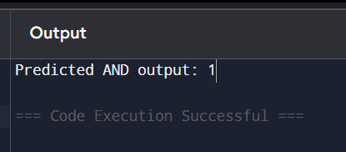

Experiment 16: Prolog Program to Sum Integers from 1 to N

Aim
To write a Prolog program that calculates the sum of integers from 1 to a given positive integer N.

Algorithm
1. Read a positive integer N.
2. If N is 0, set the sum to 0.
3. Otherwise, recursively calculate the sum from 1 to N-1.
4. Add N to the previous sum.
5. Display the final sum.

Pseudo Code
START
Read N
IF N = 0
Sum = 0
ELSE
Sum = N + sum(N - 1)
END IF
Display Sum
STOP

Prolog Code
sum_to_n(0, 0).
sum_to_n(N, Sum) :-
N > 0,
N1 is N - 1,
sum_to_n(N1, PreviousSum),
Sum is N + PreviousSum.
start :-
write('Enter a positive integer: '),
read(N),
sum_to_n(N, Sum),
write('Sum from 1 to '),
write(N),
write(' is '),
write(Sum).

Sample Input
?- start.
Enter a positive integer: 5.

Sample Output
Sum from 1 to 5 is 15

Result
Thus, the Prolog program to calculate the sum of integers from 1 to N was executed successfully.

